1. POST – Add courses

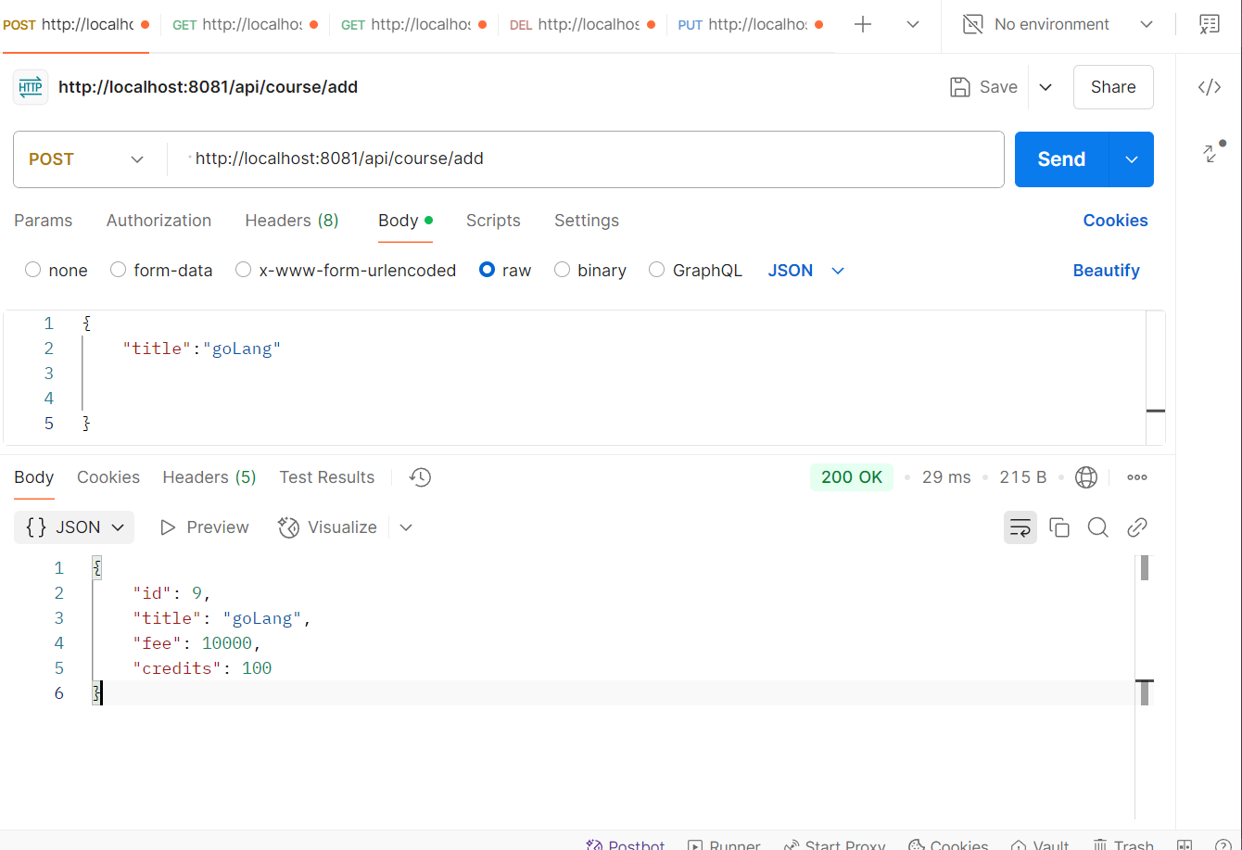

1. GET - single course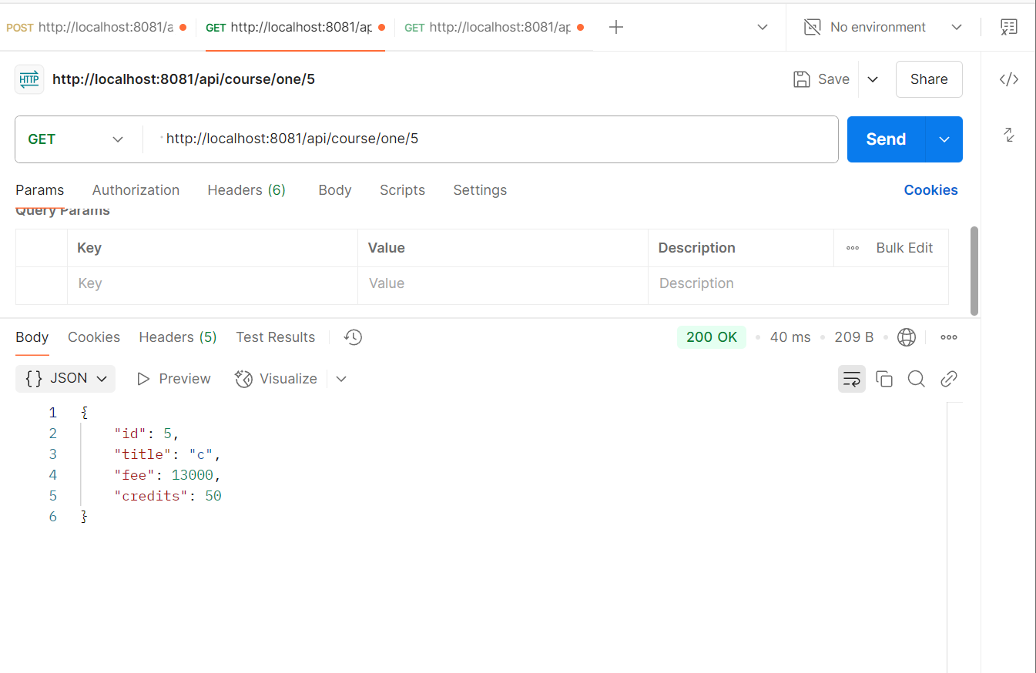
2. GET – Get All

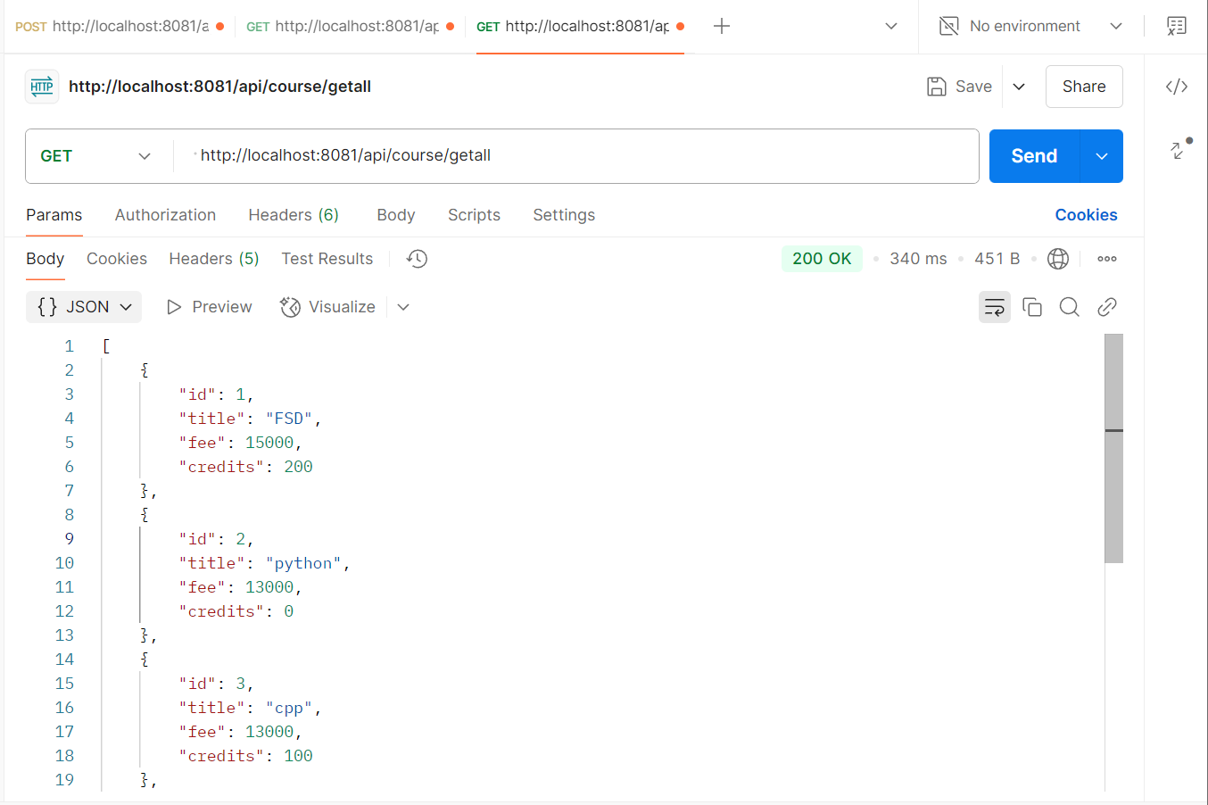

1. DELETE – by ID

1. PUT – update using id [ @RequestParam and @ RequestBody]

